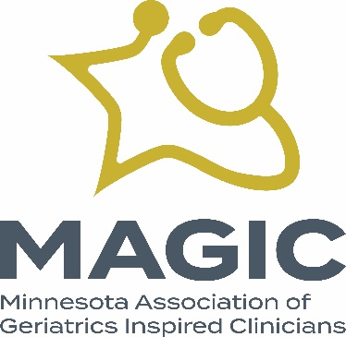

MAGIC 2022 Annual Meeting Agenda
- Welcome and establish a quorum

- Thank you to our planning committee:
  - Rajean Moone
  - Ed Ratner
  - Steven Atkinson
  - Kari Everson
  - Nikki Siddons

- Thank Amanda Tufano for her years of service to the MAGIC Board and most recently for her service on the Executive Committee.

- Thank Sandy Turbes, MD for her service as new editor of TOPICS

- Vote to elect our slate of two new board members, each to serve a two-year term:
- Nikki Siddons
- Sandy Turbes

- Vote to elect our new officer:
- Treasurer/Secretary: TBD

- Thank you to our supporters
Premier:
- Genevive
Gold:
  - Acadia Pharmaceuticals
  - Health Partners/Park Nicollet
  - Medica
  - Lifespark
  - Allina Health|Aetna
  - M Health Fairview

Silver:
- University of Minnesota GWEP
- Optum
- Livio Health

Bronze:
- Ebenezer
- Compassion & Choices
- Care Providers of Minnesota
- University of Minnesota Center for Healthy Aging & Innovation
- LeadingAge Minnesota
- Eden Senior Care
- Neurocrine Biosciences
- TEVA Pharmaceuticals

Thank you for your attendance at our conference and thank you to our supporters. We will see you tomorrow when registration at Midland Hills Country Club begins at 7:30 am and program begins at 8:00 am.

