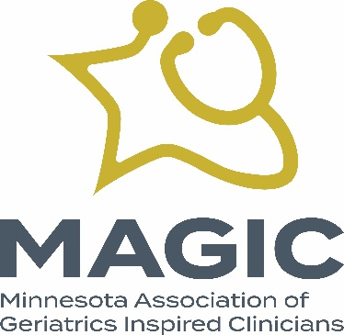

MAGIC 2023 Annual Meeting Agenda
- Welcome and establish a quorum.

- Thank you to our planning committee:

  - Rajean Moone
  - Ed Ratner
  - Steven Atkinson
  - Kari Everson
  - Nikki Siddons
  - Heidi Holste, Executive Director
  - Robin Ronayne, Project Manager

- Vote to elect our slate of two new board members, each to serve a two-year term:

  - Ben Rosenstein, MD
  - Paul Takahashi, MD

- Vote to elect our new officers:

  - President: Simon Mittal, MD
  - President Elect: Nicole Siddons, DNP, APRN, FNP-C

- Bylaws Amendment #1: Increasing Board Seats

- The MAGIC Board recommends expanding the maximum number of Board members in the bylaws from 13 to 15.

- Bylaws Amendment #2: Bylaws Amendment - Quorum Change

- The MAGIC Board recommends replacing Section 6 “A quorum of a meeting of the board is at least a simple majority of all directors in office.” with “A quorum of a meeting of the board is 50% of all directors in office.”

- Thank you for your attendance at our conference and thank you to our supporters.

- We will see you tomorrow when registration at Midland Hills Country Club begins at 7:30 am and program begins at 8:00 am.

